**The UDP Bandmap**

Aki Yoshida JA1NLX

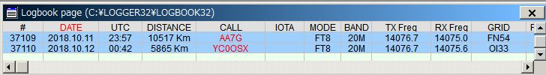

UBM_6B

When “Log additional info from Logbook Entry Window” is checked, the following data entered into the Logbook Entry Window is logged with the UDP logging information if not already in the UDP logging message.

TX_PWR, QTH, ADDRESS, COMMENT, NAME, STATE, and CNTY.

If you want to set the Logger32 frequency/mode from WSJT-X/JTDX then check “Allow WSJT/JTDX to set frequency/mode” Logger32 radio port must be closed. See paragraph 5.4 Start for related explanation and paragraph 5.0 Band Mode Selection Setup in the Logbook Entry Window section.

If you are interested in cross band satellite operation then you may need to check “Setup cross band satellite frequency offsets” and configure frequency offsets.  
See more details in paragraph 11.0 Tips.

### 

UBM_6B1

### Sub menu for Signal level

If you want to see the signal level then check "Show signal level" and click ”Signal level” to select the signal level type, SNR or S units.

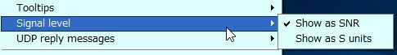

UBM_6C

## 11.0. TIPS

If you have "Show only callsigns calling CQ" and "Show only highlighted callsigns" checked then the only station that are highlighted and calling CQ will show.

The BLOCK COUNTRY and BLOCK CONTINENT options look for a Country/Continent match with the Logger32 Current Operator.  If you have the Logger32 operator set to "At the Beach" or "Club Station" or something other than the callsign of where you are operation, the results will be unpredictable.

Try to change settings of "DX Spot highlight colors" in DX Spot Window and settings of "Setup phone/digital modes" in Tools menu. It affects the way to display highlight colors and tooltips in UDP Bandmap.

## UDP message debug window

This Debug window is very useful to check problem. Click "Show debug window" in Config menu to show debug window. The Reply message is displayed in Red text.

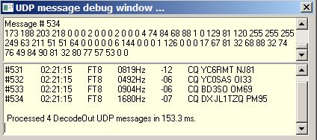

UBM_15

## Cherry-picking event viewer

The cherry-picking event viewer shows all steps regarding cherry-picking. You may understand what is happening now. It shows the number of callsigns decoded this cycle at the bottom right hand corner.

## 

UBM_16

## Manual calling event viewer

The manual calling event viewer shows all steps regarding manual calling. You may understand what is happening now.

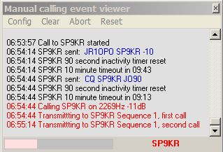

UBM_17

## UDP port settings to use Logger32, JTDX and GridTracker

The following chart displays the recommended settings to use Logger32, JTDX and GridTracker. The IP address and Port # can be changed if needed, however it should be always same for each UDP port respectively.

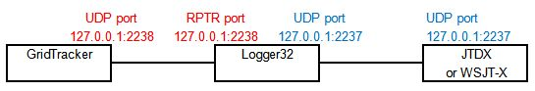

UBM_18

## Direct clicking on callsign in WSJT/JTDX

This is a TIP for those WSJT/JTDX users who prefer not to use the cherry-picker or the manual calling features of Logger32, but log directly to Logger32 by UDP.

Clicking on a callsign in WSJT/JTDX starts a QSO sequence independent of Logger32. With the right menus selected in Logger32 the Logbook Entry Window is populated with the callsign, auto lookup of the callsign is done, and the rotor is turned. The additional Logbook Entry Window information is added and the logged QSO. When Logger32 detects the WSJT/JTDX has dropped TxEnable, then the Logbook Entry Window is cleared.

You need following settings:

On the UDP BandMap window, click CONFIG | CHERRY-PICKING OPTIONS and check CLEAR/ENTER LOGBOOK ENTRY WHEN SENDING UDP REPLY MESSAGES (this tells Logger32 to put the callsign in the Logbook Entry Window); and,

On the UDP BandMap window, click CONFIG | LOGGING OPTIONS and check LOG ADDITIONAL INFO FROM LOGBOOK ENTRY WINDOW (this tells Logger32 to add any additional information to the Log QSO message from WSJT/JTDX.

## QO-100 satellite QSO using Logger32/WSJTX (or JTDX)/SDR-Console

When using SDR-Console for QO-100 it looks to Logger32 (or any logging program) like one radio or one VFO is connected. Unfortunately it is on 3CM (10GHz). Users transmit on 13CM, so QSOs must be logged with FREQ of 2.4GHz (13CM), not 10GHz that is received from SDR-Console, and FREQ_RX of 10GHz (3CM). So, Logger32 must turn everything upside down and automagically calculate the offset

Setup has two steps. First, look at the Radio Control Panel menus and click LOGGING FREQUENCY SETUP and check this option - This shifts the 3CM from SDR-Console down to 13CM, the band the operator will make the QSOs.



UBM_19

Second to allow for correct logging of FT4/FT8 QSOs from WSJT/JTDX, click the CONFIG | LOGGING OPTIONS | CROSS BAND SATELLITE FREQUENCY OFFSETS and setup the option like this:

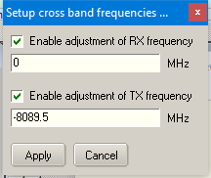

UBM_20

This adjusts the QO-100 Tx/Rx split for QSO logging UDP messages received from WSJT/JTDX. Setup the two options as described, and your Logger32 Logbook Entry Window looks like this.

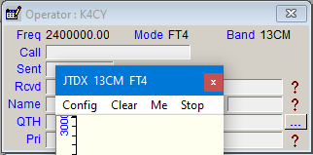

UBM_21